**U.S. Department of Energy (DOE)  
Clean Energy to Communities (C2C) Program**

Summary of Technical Assistance (TA) Support

|  |
| --- |
| Marker with solid fill |
| Icon  Description automatically generatedBuildings |
| Icon  Description automatically generatedClean Power |
| Climate Mitigation and Resilience |
| Cross-Sectoral Justice |
| A picture containing text, clipart  Description automatically generatedJobs and Economic Development |
| Icon  Description automatically generatedMobility |

**Barrio Carite, Puerto Rico**

TA Scope

During the month of April 2023, the National Renewable Energy Laboratory (NREL) and the Oak Ridge National Laboratory (ORNL) provided technical support to Finca Caleli in the following ways:

* Light touch consultation calls with microgrid subject matter experts (SMEs) Bharat Solanki and Ben Olis
* References to another microgrid project on-island and partnership between ORNL and University of Puerto Rico, Mayaguez.

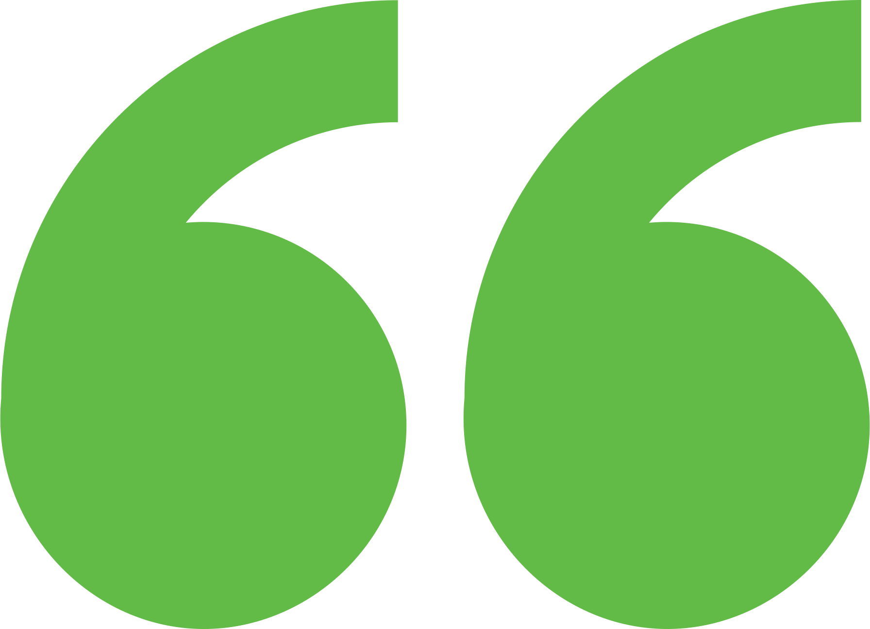 Impact

The applicant better understands the range of resilience solutions, the required partnerships, and the necessary data to plan a microgrid project. Hopefully the applicant will be better equipped to form a project team and scope that has broader community impact if and when they apply to future U.S. Department of Energy technical assistance programs.

Background

Photo goes here.

*Delete this box before publishing.*

**Background**

Ann Arbor is a city of approximately 122,000 people located in southeast Michigan. The city and its residents are leaders in sustainability and climate action. Their A2ZERO Climate Action Plan outlines their just transition pathway to community-wide carbon neutrality by 2030. With equity as a focus, they are implementing strategies to improve home energy efficiency (EE) and electrify appliances. Toward this, the city wants to explore community geothermal heating and cooling to serve a variety of building types including rental and affordable housing. The city has applied to DOE’s Geothermal Heating and Cooling Design and Deployment program and garnered the support of City Council to pursue these projects, but they need to understand the concept’s feasibility in order to make a “go, no-go” decision.

Barrio Carite is the largest community in Guayama County, Puerto Rico. Impacted by Hurricanes Irma, Maria, and Fiona, this community has not seen much recovery since Maria. According to the applicant, many homes still have Federal Emergency Management Agency blue tarp roofs. Residents are dependent on the Puerto Rico Electric Power Authority legacy system for their power and water during disruptions that disable pumping stations. This remote community lies in the central mountains running through the middle of the island. Power interruptions are frequent. Citizens use diesel and gas generators to power their homes. The applicant (Kevin Shockey) is the owner of a farm (Finca Caleli) who is interested in a resilience project that could potentially benefit the broader community. The C2C Community Lead matched Kevin with microgrid SMEs at NREL and ORNL for a few light touch consultation calls. Ultimately, the applicant was encouraged to re-apply to Expert Match when they had a more concrete concept with more buy-in from community partners and neighbors.

Expert Match Team

**Chrissy Scarpitti**  
Community Lead, Main Expert Match Point of Contact, NREL

**Ben Olis**  
Microgrid Expert, ORNL

**Bharat Solanki**  
Microgrid Expert, NREL

**Sika Gadzanku**  
C2C Expert Match Program Manager, NREL

Community Team

**Kevin Shockey**  
Owner Finca Caleli

For more information, visit:  
**energy.gov/eere/clean-energy-communities-program**

August 2024